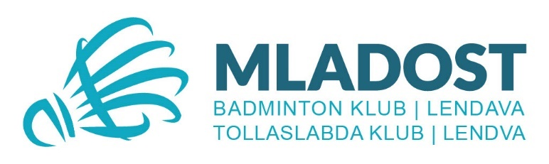
INVITATION

21st INTERNATIONAL
BADMINTON TOURNAMENT

RSL SILVER SHUTTLECOCK
OF LENDAVA 2026

ORGANIZER: | Badminton Club MLADOST LENDAVA
VENUE: | Lendava (Slovenia)  Sports hall of DSŠ Lendava (8 courts)
DATES: | Saturday, 18 April 2026, at 9.00  Sunday, 19 April 2026, at 9.00
EVENTS: | Boy’s and girl’s singles and doubles (no mixed doubles)  U17 – born in 2010 or younger  U15 – born in 2012 or younger  U13 – born in 2014 or younger  U11 – born in 2016 or younger
MODE OF PLAY: | Singles: first stage in groups of 3-4, second stage K.O. system  Doubles: simple K.O. system
SHUTTLES: | Only RSL official tournament shuttlecocks.  Shuttles should be provided by competitors themselves and can be bought in the hall. | 
PRIZES: | Trophies, medals and badminton equipment prizes for the first three in each event.
ENTRIES: | To: bkmladost1971@gmail.com (Entry form) or  Bojan Sekereš  Kranjčeva ulica 50  9220 LENDAVA  SLOVENIA
CLOSING DATE: | 14. April 2026
ENTRY FEES: | Singles: EUR 25,- per competitor  Doubles: EUR 15,- per competitor  Both events: EUR 35,- per competitor
ACCOMMODATION: | Private Apartments (from 25€ per person/night)  Hotel Thermal Resort Lendava (rooms and apartments); Hotel Cubis Lendava  Info: sekere.bojan@siol.net
INFORMATION: | www.mladost.si or Bojan Sekereš, sekere.bojan@siol.net; 00386 41 616 376
INSURANCE: | Each team is responsible for arranging the appropriate insurance for its team members e.g. accident, property and liability. The tournament organizers reserve the right for changes or adjustments.

